RANGLISTER 2016 kvinder – udendørs

KVINDER, senior

100 m
1. Kamille Busch Hansen (2000) 12,61
2. Laura Haslund-Christensen (2001) 13,05
3. Amalie Molander Pedersen (2000) 13,41
4. Emma Landberg (2002) 13,55
5. Cecilie Biltoft-Jensen (1994) 13,61
6. Maja Antvorskov (2002) 13,78
7. Ingeborg Falck (2004) 13,96
8. Andrea Øbro Jacobsen (2001) 14,13
9. Kamille Dalsgaard Andersen (2003) 14,15
10. Signe Dam (2002) 14,20

Medvind:
1. Laura Haslund-Christensen (2001) 13,03
2. Signe Dam (2002) 13,88

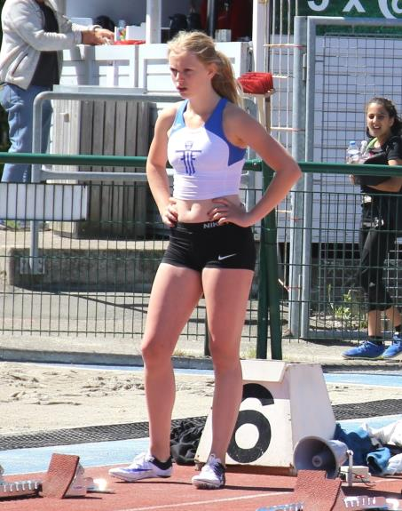
Kamille Busch Hansen

200 m
1. Kamille Busch Hansen (2000) 25,94
2. Laura Haslund-Christensen (2001) 27,54
3. Amalie Molander Pedersen (2000) 27,71
4. Kamille Dalsgaard Andersen (2003) 27,93
5. Cecilie Biltoft-Jensen (1994) 28,58
6. Angela Muki (2003) 28,77
7. Ingeborg Falck (2004) 28,99
8. Signe Dam (2002) 29,57
9. Carolinie Søndergaard (2002) 29,80
10. Emma Landberg (2002) 30,24

Medvind:
1. Amalie Molander Pedersen (2000) 27,55
2. Cecilie Biltoft Jensen (1994) 28,15
3. Kathrine Dahl (1979) 29,32
4. Signe Dam (2002) 29,57
5. Nikoline L. Laursen (2000) 30,01

300 m
1. Laura Haslund-Christensen (2001) 42,91
2. Cecilie Biltoft Jensen (1994) 45,26
3. Ellen Nørding Christensen (2003) 45,54
4. Signe Dam (2002) 46,34
5. Kathrine Dahl (1975) 47,48

400 m
1. Ellen Nørding Christensen (2003) 63,95
2. Laura Haslund-Christensen (2001) 63,99
3. Cecilie Biltoft Jensen (1994) 64,45
4. Kamille Dalsgaard Andersen (2003) 64,88
5. Katinka Valentin Hald (2000) 65,10
6. Kathrine Dahl (1975) 68,06
7. Greta Keisala (2006) 76,25
8. Mathilde Meedom Kløv (2006) 76,44
9. Caroline Søndergaard (2002) 77,44
10. Kathrine Rogers (2003) 78,32

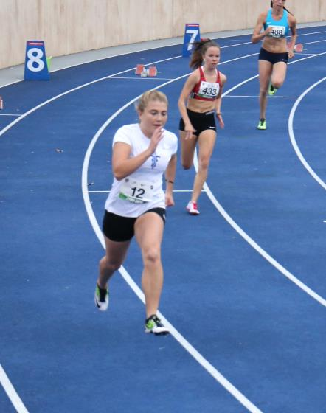
Cecilie Biltoft Jensen

800 m
1. Ellen Nørding Christensen (2003) 2.25,94
2. Laura Haslund-Christensen (2001) 2.28,82

800 m fortsat
3. Kamille Dalsgaard Andersen (2003) 2.28,99
4. Amalie Boeck (2003) 2.36,57
5. Rie Oreskov (2003) 2.39,66
6. Nikoline L. Laursen (2000) 2.49,86
7. Amalie Molander Pedersen (2000) 2.50,24
8. Greta Keisala (2006) 3.00,65
9. Marie Meyer Have (2003) 3.00,73
10. Mathilde Meedom Kløv (2006) 3.04,09

1000 m
1. Kamille Dalsgaard Andersen (2003) 3.14,74
2. Ellen Nørding Christensen (2003) 3.20,62
3. Amalie Boeck (2003) 3.25,60
4. Grete Keisala (2006) 3.44,47
5. Mathilde Meedom Kløv (2006) 3.52,30

1500 m
1. Ellen Nørding Christensen (2003) 5.07,37
2. Kamille Dalsgaard Andersen (2003) 5.08,21
3. Amalie Boeck (2003) 5.21,73
4. Greta Keisala (2006) 5.49,73
5. Cecilie Biltoft-Jensen (1994) 6.04,78
6. Berit El-Nasser (1964) 6.10,06

3000 m
1. Kamille D. Andersen (2003) 11.35,21
2. Amalie Boeck (2003) 12.11,31

100 m hæk
1. Sofie Tidsvilde (1998) 16,27

400 m hæk
1. Nikoline Lindegaard Laursen (2000) 75,72

4 x 100 m
1. Cecilie Biltoft-Jensen (1994) 51,38
Sophia Kmit Mikkelsen (1999)
Amalie Molander Pedersen (2000)
Kamille Busch Hansen (2000)

Længdespring
1. Amalie Molander Pedersen (2000) 5,20
2. Sofie Tidsvilde (1998) 4,83
3. Sophia Kmit Mikkelsen (1999) 4,61
4. Maja Antvorskov (2002) 4,47
5. Emma Landberg (2002) 4,41
6. Signe Dam (2002) 4,40
7. Caroline Søndergaard (2002) 4,39
8. Ingeborg Falck (2004) 4,35
9. Laura Haslund Christenden (2001) 4,19
10. Klara Steensballe (2001) 3,98

Trespring
1. Amalie Molander Pedersen (2000) 11,12
2. Sophia Kmit Mikkelsen (1999) 10,73

Højdespring
1. Maja Antvorskov (2002) 1,49
2. Amalie Molander Pedersen (2000) 1,45
3. Marie Meyer Have (2003) 1,37
4. Rie Oreskov (2003) 1,34
5. Frida Hagen Nielsen (2003) 1,31
6. Kathrine Rogers (2003) 1,25
6. Amalie Boeck (2003) 1,25
6. Nikoline T. Ammitzbøll (2003) 1,25
6. Rebecca Sckotz Balestra (2003) 1,25
6. Sarah Røjkjær Knudsen (2003) 1,25

Stangspring
1. Nikoline L. Laursen (2000) 1,99
2. Maja Antvorskov (2002) 1,90
3. Katrine Holst Hahn (2004) 1,50

Kuglestød
1. Amalie Molander Pedersen (2000) 9,99
2. Cæcilie Thomsen (2000) 7,40

Diskoskast
1. Amalie Molander Pedersen (2000) 29,94
2. Cæcilie Thomsen (2000) 15,56

Hammerkast
1. Cæcilie Thomsen (2000) 32,26

Spydkast
1. Amalie Molander Pedersen (2000) 25,64
2. Andrea Holm (2001) 24,41
3. Nikoline L. Laursen (2000) 21,47
PIGER, 18-19 år

100 m hæk
1. Sofie Tidsvilde (1998) 16,27

Længdespring
1. Sofie Tidsvilde (1998) 4,83

PIGER, 16-17 år

100 m
1. Kamille Busch Hansen (2000) 12,61
2. Amalie Molander Pedersen (2000) 13,41

200 m
1. Kamille Busch Hansen (2000) 25,94
2. Amalie Molander Pedersen (2000) 27,71

Medvind:
1. Amalie Molander Pedersen (2000) 27,55
2. Nikoline L. Laursen (2000) 30,01
3. Cæcilie Thomsen (2000) 32,19

400 m
1. Katinka Valentin Hald (2000) 65,10

800 m
1. Nikoline L. Laursen (2000) 2.49,86
2 Amalie Molander Pedersen (2000) 2.50,24
3. Cæcilie Thomsen (2000) 3.15,55

100 m hæk (76,2 cm)
1. Amalie Molander Pedersen (2000) 17,14
2. Nikoline L. Laursen (2000) 19,45
3. Cæcilie Thomsen (2000) 21,72

400 m hæk
1. Nikoline Lindegaard Laursen (2000) 75,72

Længdespring
1. Amalie Molander Pedersen (2000) 5,20
2. Sophia Kmit Mikkelsen (1999) 4,61

Medvind:
1. Cæcilie Thomsen (2000) 3,66

Trespring
1. Amalie Molander Pedersen (2000) 11,12
2. Sophia Kmit Mikkelsen (1999) 10,73

Højdespring
1. Amalie Molander Pedersen (2000) 1,45
2. Nikoline L. Laursen (2000) 1,24
3. Cæcilie Thomsen (2000) 1,15

Stangspring
1. Nikoline L. Laursen (2000) 1,99

Kuglestød (3,0 kg)
1. Amalie Molander Pedersen (2000) 11,80
2. Cæcilie Thomsen (2000) 8,86
3. Nikoline L. Laursen (2000) 6,44

Diskoskast (1,0 kg)
1. Amalie Molander Pedersen (2000) 29,94
2. Cæcilie Thomsen (2000) 15,56

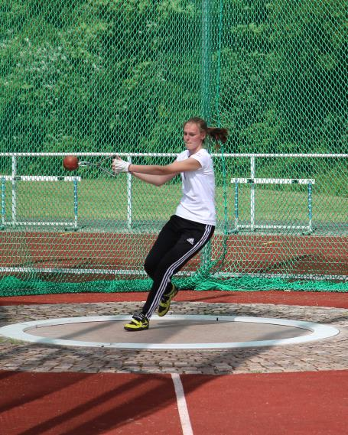
Amalie Molander Pedersen

Hammerkast (3,0 kg)
1. Amalie Molander Pedersen (2000) 43,58
1. Cæcilie Thomsen (2000) 38,13

Vægtkast (7,26 kg)
1. Amalie Molander Pedersen (2000) 13,91

Spydkast (500 gr)
1. Amalie Molander Pedersen (2000) 34,98
2. Nikoline L. Laursen (2000) 21,00
3. Cæcilie Thomsen (2000) 17,03

7-kamp
1. Amalie Molander Pedersen (2000) 3656 p
2. Nikoline L. Laursen (2000) 2530 p

Medvind
1. Nikoline L. Laursen (2000) 2538 p
2. Cæcilie Thomsen (2000) 1863 p

PIGER, 14-15 år

100 m
1. Laura Haslund-Christensen (2001) 13,43
2. Emma Landberg (2002) 13,55
3. Maja Antvorskov (2002) 13,78
4. Andrea Øbro Jacobsen (2001) 14,13
5. Signe Dam (2002) 14,20
6. Caroline Søndergaard (2002) 14,32
7. Karla Kaas Nørgaard (2002) 14,61
8. Klara Stensballe (2001) 15,43

100 m ( fortsat )
9. Michella W. Andresen (2002) 15,59
10. Anne Sofie B. Legård (2002) 16,71

Medvind:
1. Laura Haslund-Christensen (2001) 13,03
2. Signe Dam (2002) 13,88
3. Andrea Holm (2001) 14,78

200 m
1. Laura Haslund-Christensen (2001) 27,54
2. Signe Dam (2002) 29,57
3. Carolinie Søndergaard (2002) 29,80
4. Emma Landberg (2002) 30,24
4. Andrea Øbro Jacobsen (2001) 31,52

Medvind:
1. Signe Dam (2002) 29,57
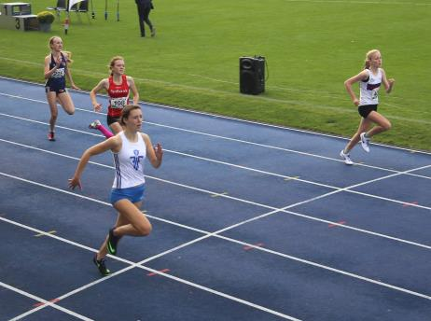
Laura Haslund-Christensen

300 m
1. Laura Haslund-Christensen (2001) 42,91
2. Signe Dam (2002) 46,34

400 m
1. Laura Haslund-Christensen (2001) 63,99
2. Caroline Søndergaard (2002) 77,44

800 m
1. Laura Haslund-Christensen (2001) 2.28,82

80 m hæk
1. Andrea Øbro Jacobsen (2001) 14,68

4 x 100 m
1. Caroline Søndergaard (2002) 55,02
Maja Antvorskov (2002)
Signe Dam (2002)
Emma Landberg (2002)

Længdespring
1. Maja Antvorskov (2002) 4,47
2. Emma Landberg (2002) 4,41
3. Signe Dam (2002) 4,40
4. Caroline Søndergaard (2002) 4,39
5. Laura Haslund Christenden (2001) 4,19
6. Klara Stensballe (2001) 3,98

7. Karla Kaas Nørgaard (2002) 3,97
8. Michella W. Andresen (2002) 3,77
9. Andrea Øbro Jacobsen (2001) 3,72
10. Anna Sofie B. Legård (2002) 3,33

Højdespring
1. Maja Antvorskov (2002) 1,49

Kuglestød ( 3 kg )
1. Andrea Holm (2001) 9,51
2. Marie Molander Pedersen (2001) 7,77
3. Maja Antvorskov (2002) 7,49
4. Laura Haslund-Christensen (2001) 7,39
5. Karla Kaas Nørgaard (2002) 6,89
6. Emma Landberg (2002) 6,82
7. Klara Stensballe (2001) 6,59
8. Anna Sofie B. Legård (2002) 6,28
9. Signe Dam (2002) 5,80
10. Caroline Søndergaard (2002) 5,70
11. Andrea Øbro Jacobsen (2001) 5,69

Diskoskast ( 0,75 kg )
1. Marie Molander Pedersen (2001) 19,96

Spydkast (500 gr )
1. Andrea Holm (2001) 21,51
2. Emma Landberg (2002) 13,30
3. Klara Stensballe (2001) 12,09

Hammerkast (3 kg)
1. Marie Molander Pedersen (2001) 18,08

PIGER, 12-13 år

80 m løb
1. Angela Muki (2003) 10,99
2. Ingeborg Falck (2004) 11,10
3. Ellen Nørding Christensen (2003) 11,24
4. Kamille D. Andersen (2003) 11,28
5. Kathrine Rogers (2003) 12,17

80 m løb ( fortsat )
6. Amalie Boeck (2003) 12,28
7. Sonia Wendelboe Hansen (2004) 12,29
8. Frida Hagen Nielsen (2003) 12,37
8 Marie Meyer Have (2003) 12,37
10. Kathrine Holst Hahn (2004) 12,69
11. Rie Oreskov (2003) 12,77
12. Rebecca Sckotz Balestra (2003) 12,80
13. Sarah Røjkjær Knudsen (2003) 13,03
14. Denice UgleholtPedersen (2003) 13,32
15. Mathilde Aguilar Skelberg (2003) 13,68
16. Nikoline T. Ammitzbøll (2003) 13,75
16. Lea Bang (2004) 13,75
18. Ida Espersen (2004) 14,99
19. Elisabeth Oksbøl Andersen (2004) 15,19

100 m
1. Ingeborg Falck (2004) 13,96
2. Kamille Dalsgaard Andersen (2003) 14,15
3. Kathrine Rogers (2003) 15,28
4. Rebecca Sckotz Balestra (2003) 15,30
5. Kathrine Holst Hahn (2004) 15,84

200 m
1. Kamille Dalsgaard Andersen (2003) 27,93
2. Angela Muki (2003) 28,77
3. Ingeborg Falck (2004) 28,99
4. Kathrine Rogers (2003) 30,69
5. Amalie Boeck (2003) 31,08
6. Marie Meyer Have (2003) 31,90

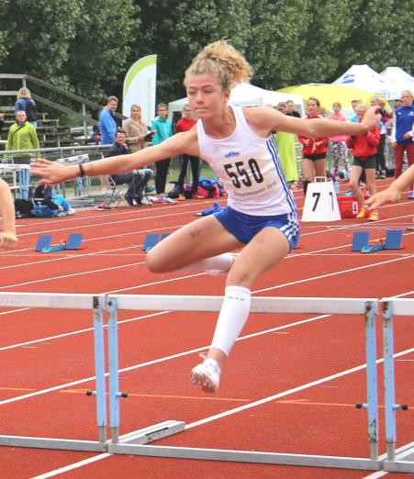
Ingeborg Falck
300 m
1. Ellen Nørding Christensen (2003) 45,54

400 m
1. Ellen Nørding Christensen (2003) 63,95
2. Kamille Dalsgaard Andersen (2003) 64,88
3. Kathrine Rogers (2003) 78,32
4. Kathrine Holst Hahn (2004) 79,34

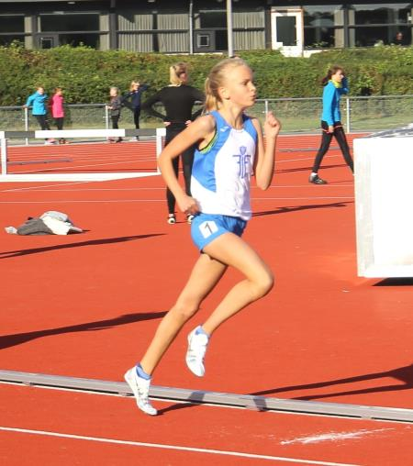
Ellen Nørding Christensen
600 m
1. Ellen Nørding Christensen (2003) 1.41,97
2. Kamille D. Andersen (2003) 1.44,01
3. Amalie Boeck (2003) 1.52,67
4. Rie Oreskov (2003) 1.55,12
5. Sofie Tamborg Karacan (2003) 2.06,42
6. Ida Espersen (2004)) 2.40,17

800 m
1. Ellen Nørding Christensen (2003) 2.25,94
2. Kamille Dalsgaard Andersen (2003) 2.28,99
3. Amalie Boeck (2003) 2.36,57
4. Rie Oreskov (2003) 2.39,66
5. Marie Meyer Have (2003) 3.00,73
6. Frida Hagen Nielsen (2003) 3.10,06

1000 m
1. Kamille Dalsgaard Andersen (2003) 3.14,74
2. Ellen Nørding Christensen (2003) 3.20,62
3. Amalie Boeck (2003) 3.25,60

1500 m
1. Ellen Nørding Christensen (2003) 5.07,37
2. Kamille Dalsgaard Andersen (2003) 5.08,21
3. Amalie Boeck (2003) 5.21,73

3000 m
1. Kamille D. Andersen (2003) 11.35,21
2. Amalie Boeck (2003) 12.11,31

60 m hæk ( h = 76,2 cm )
1. Ingeborg Falck (2004) 10,17
2. Amalie Boeck (2003) 12,15
3. Rie Oreskov (2003) 12,45
4. Frida Hagen Nielsen (2003) 12,85
5. Kathrine Holst Hahn (2004) 13,18
6. Kathrine Rogers (2003) 13,64
7. Nikoline Treumer Ammitzbøll (2003) 14,26

4 x 80 m
1. Kathrine Rogers (2003) 45,29
Rebecca Sckotz Balestra (2003)
Angela Muki (2003)
Ingeborg Falck (2004)

4x200 m
1. Amalie Boeck (2003) 2.00,07
Ingeborg Falck (2004)
Kamille D. Andersen (2003)
Ellen Nørding Christensen (2003)

Højdespring
1. Marie Meyer Have (2003) 1,37
2. Rie Oreskov (2003) 1,34
3. Frida Hagen Nielsen (2003) 1,31
4. Kathrine Rogers (2003) 1,25
4. Amalie Boeck (2003) 1,25
4. Nikoline T. Ammitzbøll (2003) 1,25
4. Rebecca Sckotz Balestra (2003) 1,25
4. Sarah Røjkjær Knudsen (2003) 1,25
9. Mathilde Aguilar Skelberg (2003) 1,20
10. Kathrine Holst Hahn (2004) 1,15
11. Rebecce Sckotz Balestra (2003) 1,10

Længdespring ( zone )
1. Ingeborg Falck (2004) 5,05
2. Angela Muki (2003) 4,82
3. Ellen Nørding Christensen (2003) 4,70
4. Kamille D. Andersen (2003) 4,67
5. Rie Oreskov (2003) 4,32
6. Amalie Boeck (2003) 4,17
7. Frida Hagen Nielsen (2003) 4,16
8. Kathrine Rogers (2003) 4,05
9. Sofie Tamborg Karacan (2003) 3,97
10. Marie Meyer Have (2003) 3,96
11. Sonia Wendelboe Hansen (2004) 3,88
12. Kathrine Holst Hahn (2004) 3,76
13. Denice Ugleholt Pedersen (2003) 3,73
14. Nikoline Treumer Ammitzbøll (2003) 3,59
15. Mathilde Aguilar Skelberg (2003) 3,02
16. Sarah Røjkjær Knudsen (2003) 2,93
17. Elisabeth Oksbøl Andersen (2004) 2,92
18. Lea Bang (2004) 2,84

Trespring (zone)
1. Ingeborg Falck (2004) 9,82

Kuglestød ( 2 kg )
1. Ingeborg Falck (2004) 9,35
2. Kamille D. Andersen (2003) 8,11
3. Rie Oreskov (2003) 7,96
4. Marie Meyer Have (2003) 7,90
5. Nikoline Treumer Ammitzbøll (2003) 7,78
6. Angela Muki (2003) 7,77
7. Ellen Nørding Christensen (2003) 6,90
8. Amalie Boeck (2003) 6,78
9. Frida Hagen Nielsen (2003) 6,72
10. Mathilde Aguilar Skelberg (2003) 6,66
11. Denice Ugleholt Pedersen (2003) 6,40
12. Sarah Røjkjær Knudsen (2003) 6,29
13. Kathrine Rogers (2003) 6,06
14. Kathrine Holst Hahn (2004) 5,08
15. Lea Bang (2004) 4,26

Spydkast
1. Rie Oreskov (2003) 24,20
2. Sarah Røjkjær Knudsen (2003) 17,34
3. Mathilde Aguilar Skelberg (2003) 13,96
4. Kathrine Rogers (2003) 13,92
5. Marie Meyer Have (2003) 12,87
6. Nikoline Treumer Ammitzbøll (2003) 12,32
7. Kathrine Holst Hahn (2004) 9,19
8. Elisabeth Oksbøl Andersen (2004) 6,29
9. Ida Espersen (2004) 4,21

3-kamp
1. Ingeborg Falck (2004) 2388 p
2. Angela Muki (2003) 2161 p
3. Kamille D. Andersen (2003) 2072 p
4. Rie Oreskov (2003) 1584 p
5. Amalie Boeck (2003) 1493 p
6. Marie Meyer Have (2003) 1436 p
7. Kathrine Rogers (2003) 1384 p
8. Frida Hagen Nielsen (2003) 1380 p
9. Kathrine Holst Hahn (2004) 1030 p
10. Sonia Wendelboe Hansen (2004) 891 p

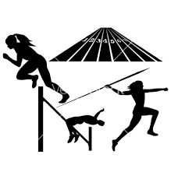

PIGER, 10-11 år

60 m
1. Greta Keisala (2006) 9,41
2. Amalie Lippert (2005) 9,55
3. Esther Alice Ravn (2006) 9,76
4. Johanna C. B. Jessen (2005) 9,83
5. Josefine D. O. Andersen (2005) 9,86
6. Kaisa Egelund (2005) 10,10
6. Ellen Vering Therkelsen (2005) 10,10
8. Mathilde Meedom Kløv (2006) 10,36
9. Ingrid Adsersen (2006) 10,39
10. Nikoline Søderberg (2005) 10,69
11. Laura Kirsten Sørensen (2005) 10,83
12. Laura Trebbien Hermann (2006) 10,97
13. Sofia Baggesen Schmidt (2006) 11,06
14. Kirsten Conrad (2005) 11,13
15. Anna Nor Ryborg Rode (2005) 11,98
16. Pippi Priess (2006) 12,20

80 m
1. Amalie Lippert (2005) 12,85
2. Johanna C. B. Jessen (2005) 12,95
3. Ellen Vering Therkelsen (2005) 13,23
4. Greta Keisala (2006) 13,34
5. Ingrid Adsersen (2006) 13,85
6. Mathilde Meedom Kløv (2006) 13,86
7. Nikoline Søderberg (2005) 14,42

Medvind
1. Esther Alice Ravn (2006) 13,70
2. Sofia Baggesen Schmidt (2006) 15,01
3. Anna Nor Ryborg Rode (2006) 15,89

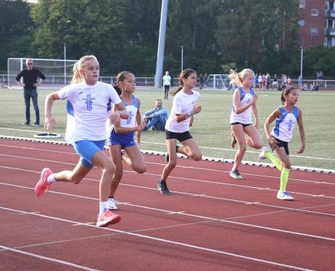
Amalie, Johanna, Ellen og Greta løber 60 m

100 m
1. Johanna C. B. Jessen (2005) 15,79
2. Amalie Lippert (2005) 15,80
3. Greta Keisala (2006) 15,86

100 m ( fortsat )
5. Ingrid Adsersen (2006) 16,89
6. Mathilde Meedom Kløv (2006) 17,13
7. Nikoline Søderberg (2005) 17,68

200 m
1. Greta Keisala (2006) 32,80
2. Johanna C. B. Jessen (2005) 35,92

400 m
1. Greta Keisala (2006) 1.16,24
2. Mathilde Meedom Kløv (2006) 1.16,44
3. Johanna C. B. Jessen (2005) 1.20,50
4. Josefine D. O. Andersen (2005) 1.24,92
5. Esther Alice Ravn (2006) 1.27,47

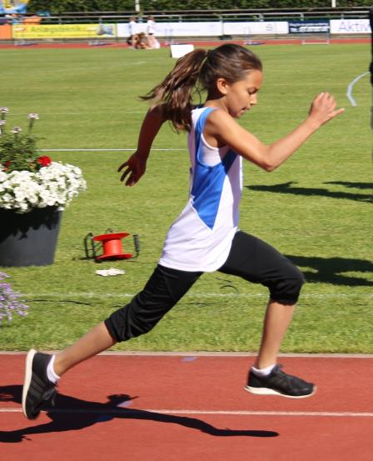
Greta Keisala
600 m
1. Greta Keisala (2006) 2.05,56
2. Mathilde Meedom Kløv (2006) 2.09,48
3. Josefine D. O. Andersen (2005) 2.20,50
4. Johanna C. B. Jessen (2005) 2.21,23
5. Ingrid Adsersen (2006) 2.22,96

800 m
1. Greta Keisala (2006) 3.00,65
2. Mathilde Meedom Kløv (2006) 3.04,09
3. Johanna C. B. Jessen (2005) 3.21,22
4. Ingrid Adsersen (2006) 3.35,68

1000 m
1. Greta Keisala (2006) 3.44,47
2. Mathilde Meedom Kløv (2006) 3.52,30
3. Johanna C. B. Jessen (2005) 4.22,03

1500 m
1. Greta Keisala (2006) 5.49,73
2. Mathilde Meedom Kløv (2006) 6.32,55
3. Johanna C. B. Jessen (2005) 7.00,86

60 m hæk ( h = 68,7 cm )
1. Johanna C. B. Jessen (2005) 12,40
2. Mathilde Meedom Kløv (2006) 14,41

4 x 60 m
1. Johanna C. B. Jessen (2005) 37,41
Ellen Vering Therkelsen (2005)
Amalie Lippert (2005)
Greta Keisala (2006)

4 x 80 m
1. Johanna C. B. Jessen (2005) 52,98
Amalie Lippert (2005)
Mathilde Meedom Kløv (2006)
Greta Keisala (2006)

4 x 200 m
1. Johanna C. B. Jessen (2005) 2.15,97
Ellen Vering Therkelsen (2005)
Amalie Lippert (2005)
Greta Keisala (2006)

Længdespring
1. Amalie Lippert (2005) 4,02
2. Ellen Vering Therkelsen (2005) 3,86
3. Johanna C. B. Jessen (2005) 3,85
2. Ellen Vering Therkelsen (2005) 3,86
4. Greta Keisala (2006) 3,77
5. Kaisa Egelund (2005) 3,76
6. Josefine D. O. Andersen (2005) 3,55
7. Esther Alice Ravn (2006) 3,35
8. Mathilde Meedom Kløv (2006) 3,34
9. Ingrid Adsersen (2006) 3,30
10. Nikoline Søderberg (2005) 3,29
11. Laura Kirsten Sørensen (2005) 3,22
12. Kirsten Conrad (2005) 3,06
13. Maria Tamborg Karacan (2005) 3,05
14. Sofia Baggesen Schmidt (2006) 3,02
15. Laura Trebbien Hermann (2006) 2,82
16. Alma Marie Dyhr (2006) 2,36
17. Pippi Priess (2006) 2,26
18. Anna Nor Ryborg Rode (2006) 2,24

Medvind
1. Ellen Vering Therkelsen (2005) 3,92
2. Anna Nor Ryborg Rode (2006) 2,29

Højdespring
1. Johanna C. B. Jessen (2005) 1,20
2. Amalie Lippert (2005) 1,16

Højdespring ( fortsat )
3. Mathilde Meedom Kløv (2006) 1,13
4. Nikoline Søderberg (2005) 1,10
5. Greta Keisala (2006) 1,05
6. Esther Alice Ravn (2006) 0,95
6. Ingrid Adsersen (2006) 0,95
8. Sofia Baggesen Schmidt (2006) 0,90
8. Pippi Priess (2006) 0,90

Kuglestød ( 2 kg )
1. Sofia Baggesen Schmidt (2006) 6,41
1. Ellen Vering Therkelsen (2005) 6,41
3. Amalie Lippert (2005) 6,18
4. Josefine D. O. Andersen (2005) 6,13
5. Mathilde Meedom Kløv (2006) 5,87
6. Johanna C. B. Jessen (2005) 5,50
7. Kaisa Egelund (2005) 5,35
8. Nikoline Søderberg (2005) 5,31
9. Esther Alice Ravn (2006) 5,29
10. Laura Kirsten Sørensen (2005) 5,01
11. Ingrid Adsersen (2006) 4,87
12. Greta Keisala (2006) 4,56
13. Kirsten Conrad (2005) 4,54
14. Alma Marie Dyhr (2006) 3,54
15. Laurs Trebbien Hermann (2006) 3,30
16. Pippi Priess (2006) 3,24

Diskoskast (0,75 kg)
1. Mathilde Meedom Kløv (2006) 10,88
Boldkast
1. Ellen Vering Therkelsen (2005) 26,45
2. Johanna C. B. Jessen (2005) 21,20
3. Kaisa Egelund (2005) 20,48
4. Mathilde Meedom Kløv (2006) 20,38
5. Greta Keisala (2006) 20,36
6. Nikoline Søderberg (2005) 20,25
7. Johanna C. B. Jessen (2005) 19,94
8. Esther Alice Ravn (2006) 17,26
9. Pippi Priess (2006) 15,89
10. Ingrid Adsersen (2006) 12,23

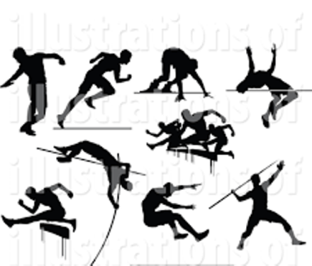

PIGER, indtil 9 år

40 m
1. Esther Falck (2008) 7,18
2. Louise Lehman Jensen (2008) 8,01
3. Isabel Pignat Larsen (2007) 7,85
4. Louise C. B. Jessen (2007) 7,91
5. Alba Sinclair (2008) 7,93
6. Elsa Kyster Hvelplund (2008) 7,96
7. Wilma C. A. Rasmussen (2007) 7,99
8. Annmaja W. Ankerstjerne (2008) 8,13
9. Sofia Bennekov Butzow (2008) 8,14
10. Josephine B. Rasmussen (2008) 8,18
11. Melanie Isabell Ø. Jørgensen (2007) 8,25
12. Freja C. Askov-Hansen (2007) 8,52
13. Agnes Nissen (2008) 8,58
14. Aline Hedegård Bruhn (2008) 8,61
15. Vera Knudstrup Trolle (2008) 8,72
16. Yasmin Hakkouni-Gourram (2008) 8,73
17. Alberte Strægaard Lastein (2008) 8,92

Medvind
1. Wilma C. A. Rasmussen (2007) 7,78
2. Magda Lacarrere (2008) 7,94

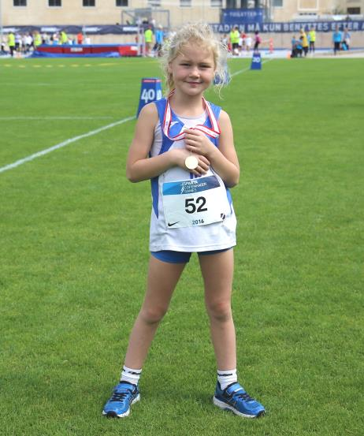
Esther Falck

60 m
1. Esther Falck (2008) 10,24
2. Melanie Isabell Ø. Jørgensen (2007) 10,8
2. Elsa Kyster Hvelplund (2008) 10,8
4. Wilma C. A. Rasmussen (2007) 11,48
5. Freja C. Askov-Hansen (2007) 11,4
6. Louise C. B. Jessen (2007) 11,86
7. Bella Havmand (2008) 12,3

80 m
1. Esther Falck (2008) 13,98
2. Magda Lacarrere (2008) 15,11
3. Melanie Isabell Ø. Jørgensen (2007) 15,51
4. Elsa Kyster Hvelplund (2008) 15,69

Medvind
1. Wilma C. A. Rasmussen (2007) 14,79
2. Felicia Nansubuga (2007) 15,11
3. Freja C. Askov-Hansen (2007) 15,48
4. Bella Havmand (2008) 17,02
5. Alberte Strægaard Lastein (2008) 18,89

200 m
1. Esther Falck (2008) 37,69
2. Louise C. B. Jensen (2007) 44,44

400 m
1. Esther Falck (2008) 1.30,12
2. Wilma C. A. Rasmussen (2007) 1.30,81
3. Louise C. B. Jessen (2007) 1.44,79
4. Elsa Kyster Hvelplund (2008) 1.49,11
5. Isabel Pignat Larsen (2007) 1.58,77

600 m
1. Freja C. Askov-Hansen (2007) 2.40,11
2. Magda Lacarrere (2008) 2.42,98
3. Louise C. B. Jessen (2007) 2.59,70

4 x 60 m
1. Louise C. B. Jessen (2007) 44,57
Elsa Kyster Hvelplund (2008)
Esther Falck (2008)
Rina Marie Brandt (2009)

4 x 80 m
1. Melanie Isabell Ø. Jørgensen (2007) 65,60
Freja C. Askov-Hansen (2007)
Elsa Kyster Hvelplund (2008)
Esther Falck (2008)

4 x 200 m
1. Melanie Isabell Ø. Jørgensen (2007) 2.50,26
Wilma C. A. Rasmussen (2007)
Magda Lacarrere (2008)
Esther Falck (2008)

Længdespring ( zone )
1. Esther Falck (2008) 3,17
2. Elsa Kyster Hvelplund (2008) 3,16
3. Melanie Isabell Ø. Jørgensen (2007) 2,98
4. Alba Sinclair (2008) 2,89

Længdespring ( fortsat )
5. Wilma C. A. Rasmussen (2007) 2,78
6. Isabel Pignat Larsen (2007) 2,75
6. Felicia Nansubuga (2007) 2,75
6. Louise C.B. Jessen (2007) 2,75
9. Annmaja W. Ankerstjerne (2008) 2,74
10. Aline Hedegård Bruhn (2008) 2,72
11. Louise Lehman Jensen (2008) 2,70
12. Bella Havmand (2008) 2,64
13. Freja C. Askov-Hansen (2007) 2,58
13. Josephine B. Rasmussen (2008) 2,58
15. Agnes Nissen (2008) 2,49
16. Yasmin Hakkouni-Gourram (2008) 2,43
17. Vera Knudstrup Trolle (2008) 2,41
18. Sofia Bennekov Butzow (2008) 2,39
19. Magda Lacarrere (2008) 2,38
20. Alberte Strægaard Lastein (2008) 2,30

Medvind
1. Louise C.B. Jessen (2007) 2,80

Højdespring
1. Louise C. B. Jessen (2007) 0,80
1. Melanie Isabell Ø. Jørgensen (2007) 0,80

Kuglestød ( 2 kg )
1. Magda Lacarrere (2008) 4,24
2. Esther Falck (2008) 4,07
3. Vera Knudstrup Trolle (2008) 4,02
4. Louise C. B. Jessen (2007) 3,78
5. Agnes Nissen (2008) 3,60
6. Josephine B. Rasmussen (2008) 3,52
7. Alba Sinclair (2008) 3,51
8. Bella Havmand (2008) 3,47
9. Wilma C. A. Jørgensen (2007) 3,44
10. Elsa Kyster Hvelplund (2008) 3,28
11. Louise Lehman Jensen (2008) 2,94
12. Freja C. Askov-Hansen (2007) 2,83
13. Yasmin Hakkouni-Gourram (2008) 2,78
14. Aline Hedegård Bruhn (2008) 2,74
15. Melanie Isabell Ø. Jørgensen (2007) 2,61
16. Sofia Bennekov Butzow (2008) 2,42
17. Alberte Strægaard Lastein (2008) 2,37

Boldkast ( 195 g )
1. Esther Falck (2008) 19,56
2. Louise C. B. Jessen (2007) 18,97
3. Wilma C. A. rasmussen (2007) 18,05
4. Freja C. Askov-Hansen (2007) 14,41
5. Elsa Kyster Hvelplund (2008) 13,79
6. Agnes Nissen (2008) 12,92
7. Melanie Isabell Ø. Jørgensen (2007) 12,51

3-kamp
1. Esther Falck (2008) 2046 p

3-kamp ( fortsat )
2. Elsa Kyster Hvelplund (2008) 1738 p
3. Alba Sinclair (2008) 1687 p
4. Louise C. B. Jessen (2007) 1621 p
5. Louise Lehman Jensen (2008) 1577 p
6. Josephine B. Rasmussen (2008) 1450 p
7. Vera Knudstrup Trolle (2008) 1272 p
8. Aline Hedegård Bruhn (2008) 1202 p
9. Freja C. Askov-Hansen (2007) 1184 p
10. Sofia Bennekov Butzow (2008) 1138 p
11. Yasmin Hakkouni-Gourram (2008) 1022 p

PIGER, indtil 7 år

40 m
1. Rina Marie Brandt (2009) 7,83
2. Laura lehman Jensen (2010) 9,19
3. Yousra Hakkouni-Gourram (2010) 10,34
4. Ines Sol Tange Paldan (2009) 10,38
5. Nanna Louise Dyhr (2010) 10,52
6. Frida Schrøder (2011) 10,91
7. Natalie I. Ø. Jørgensen (2010) 11,01

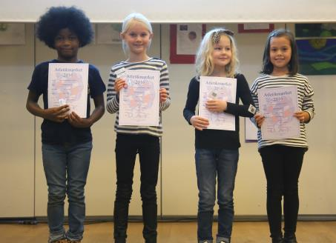
Rina Brandt til venstre sammen med Elsa Kyster Hvelplund, Esther Falck og Louise C. B. Jessen
80 m
1. Rina Marie Brandt (2009) 14,78

400 m
1. Rina Marie Brandt (2009) 1.33,67

600 m
1. Rina Marie Brandt (2009) 2.37,19

Længdespring
1. Rina Marie Brandt (2009) 3,11
2. Frida Schrøder (2011) 2,38
3. Ines Sol Tange Paldan (2009) 2,13
4. Laura lehman Jensen (2010) 2,07
5. Natalie I. Ø. Jørgensen (2010) 1,92
6. Nanna Louise Dyhr (2010) 1,67
7. Yousra Hakkouni-Gourram (2010) 1,36

Kuglestød ( 2 kg )
1. Rina Marie Brandt (2009) 4,25
3. Ines Sol Tange Paldan (2009) 2,21

3. Yousra Hakkouni-Gourram (2010) 1,88
4. Nanna Louise Dyhr (2010) 1,63
5. Laura lehman Jensen (2010) 1,58
6. Frida Schrøder (2011) 1,50

Boldkast
1. Natalie I. Ø. Jørgensen (2010) 5,49

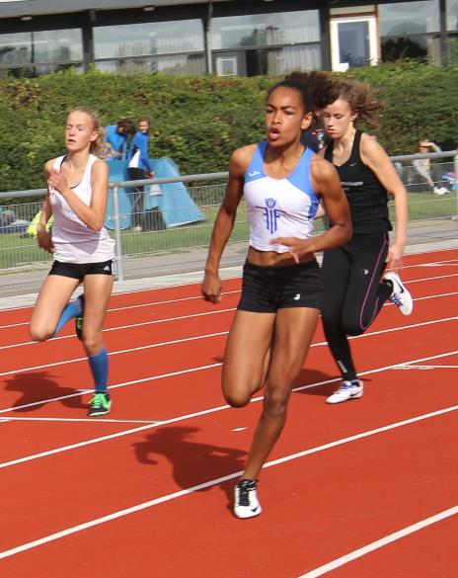
Årets Fund 2016: Angela Muki

Fr.berg den 7. december 2016 René V.

